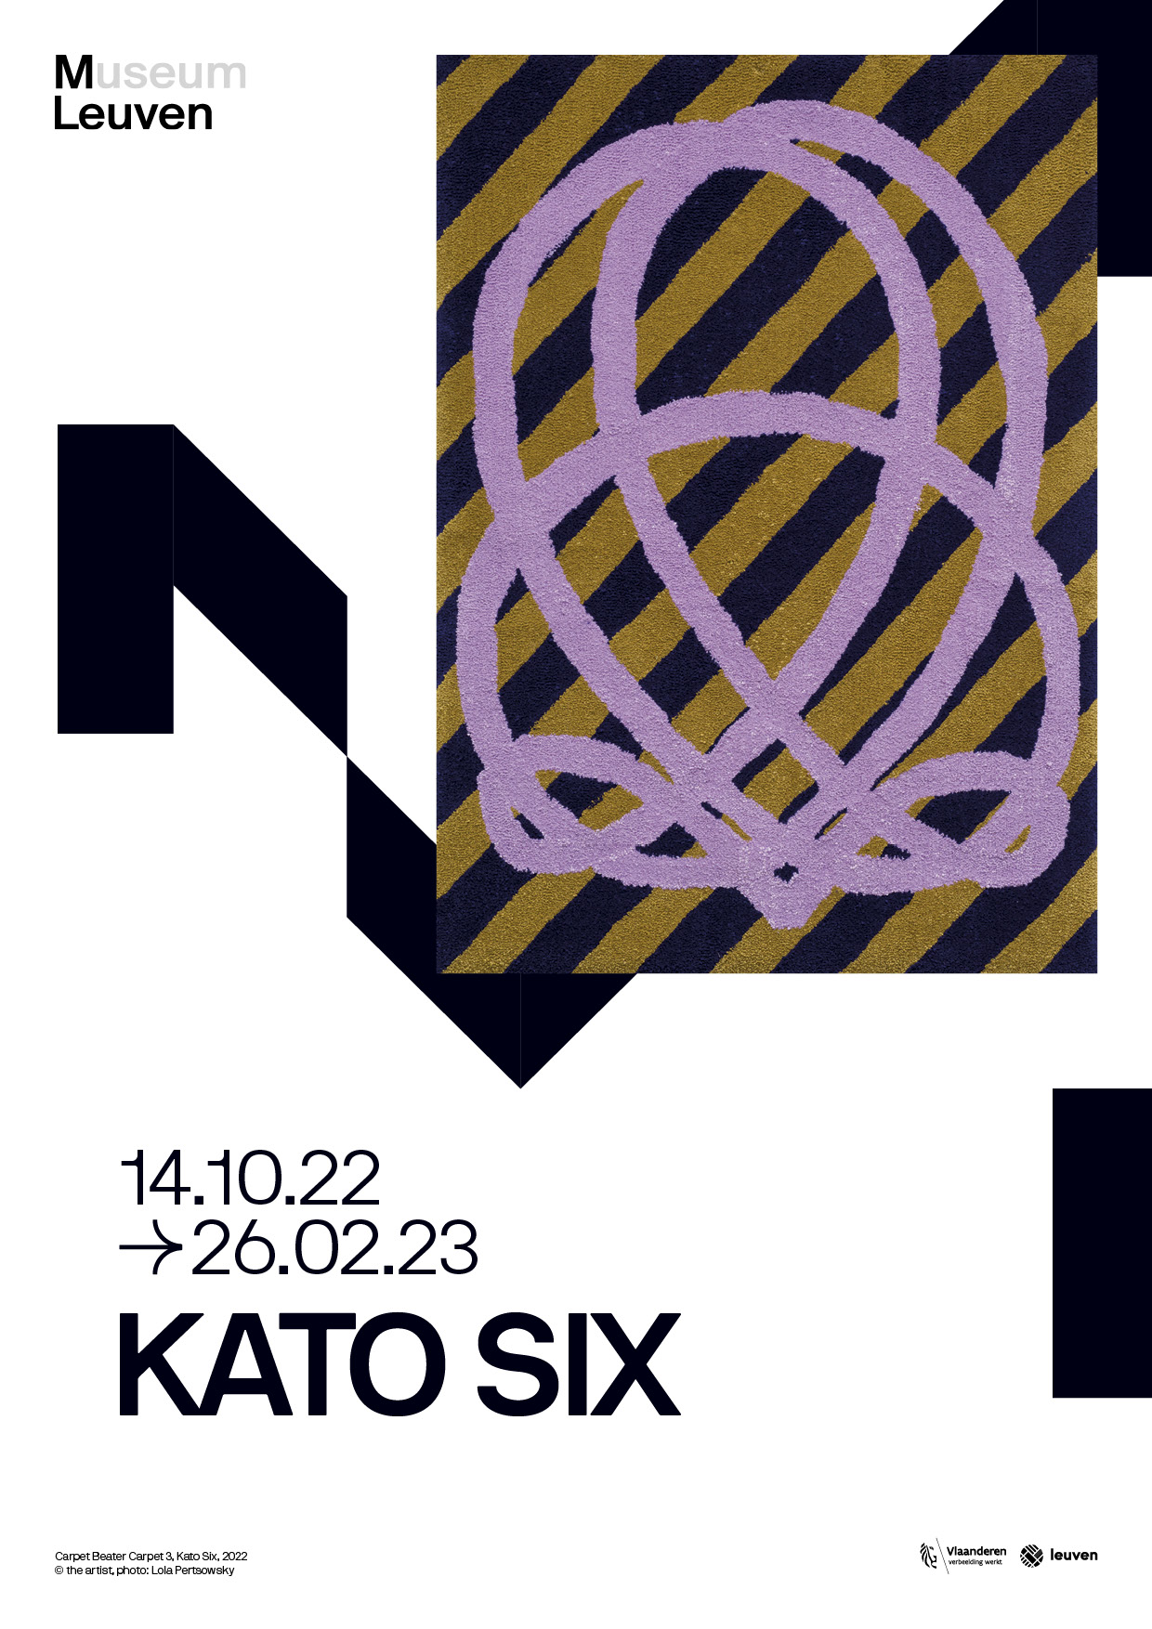

INTRODUCTION
The Belgian artist Kato Six (°1986) produces drawings, textile art, wall art and sculptures. Her artistic practice embraces a number of themes which she develops into series or ensembles. Recognizable and everyday materials and objects form the basis of an oeuvre that is a cross between abstract and figurative art. Architecture, design, domesticity and utility objects play an important role as references.
Kato Six’s artworks are the result of various techniques in which physicality and making the works herself are pivotal. The forms and materials often refer to household tasks and handicrafts such as knitting and crocheting. She also makes works out of MDF and other hard materials, such as different types of plastic. These might be Formica or solid surface – synthetics used in the interior, often mimicking natural materials. From this domestic context, she questions our relationship with nature, using landscapes to switch foreground for background and indoors for outdoors
Curator: Eva Wittocx

BIOGRAPHY
Kato Six (°1986) lives and works in Brussels. She got her master's degree in visual arts and a master's degree in graphic design from the KASK in Ghent. She complemented her studies with several residencies at Wiels (Brussels, BE, 2012), ABA (Berlin, DE, 2014), Residency Unlimited (New York, USA, 2016), Skowhegan School of Painting & Sculpture (Skowhegan, USA, 2017). Recent solo shows include 'Background Hum' at Composite in Brussels (2016), 'Spinning lines, Twisting feelings' at CHANGE-CHANGE in Budapest (2017), 'State of Matter' at VITRINE gallery in London (2019). She has also participated in several group exhibitions such as 'Conjunctions' at Peninsula Art Space in New York ( 2016), 'Heads or Tails' at DMW Gallery in Antwerp (2019) or 'The Constant Glitch' at M Leuven (2021). Her work is included in of various collections, such as at Mu.ZEE (Ostend), the Flemish Community and Cera at M Leuven.
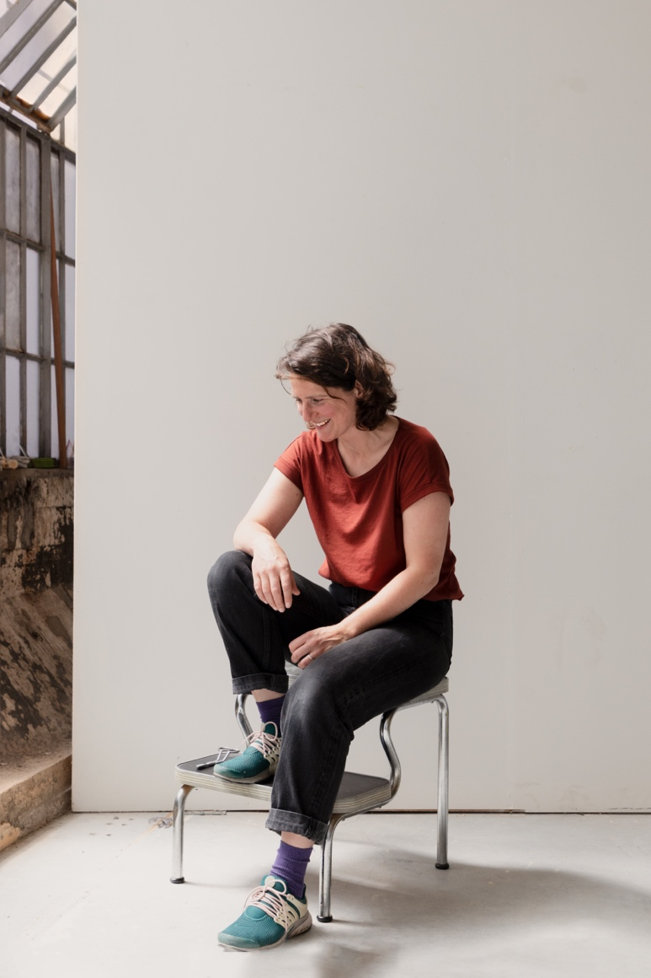

EXHIBITION
For this first comprehensive exhibition, Kato Six brings together several works for the first time. In addition to existing sculptures and drawings, she presents a new series of textile works for which she ventured into tufting, a 1950s technique for making carpets. Those works feature the curling shape of a carpet beater. A form that, like her landscapes, crochet patterns or geometric compositions - she borrows from collective memory. Mural works will also be shown in situ.
These works aim to make us reflect on the everyday or on elements from our everyday environment; to make us look differently, and possibly discover new patterns.

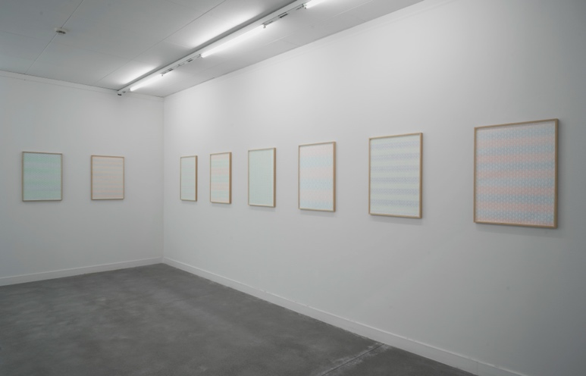
Installation view Kato Six M Leuven, 2022
© M Leuven (photo Dirk Pauwels)
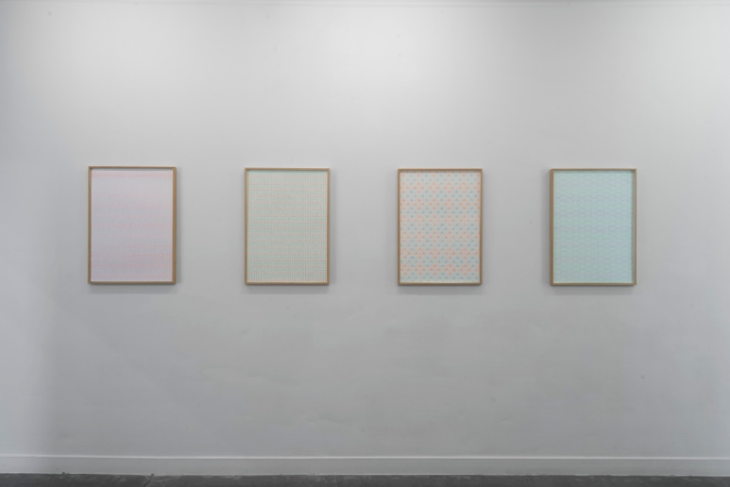
Installation view Kato Six M Leuven, 2022
© M Leuven (photo Dirk Pauwels)

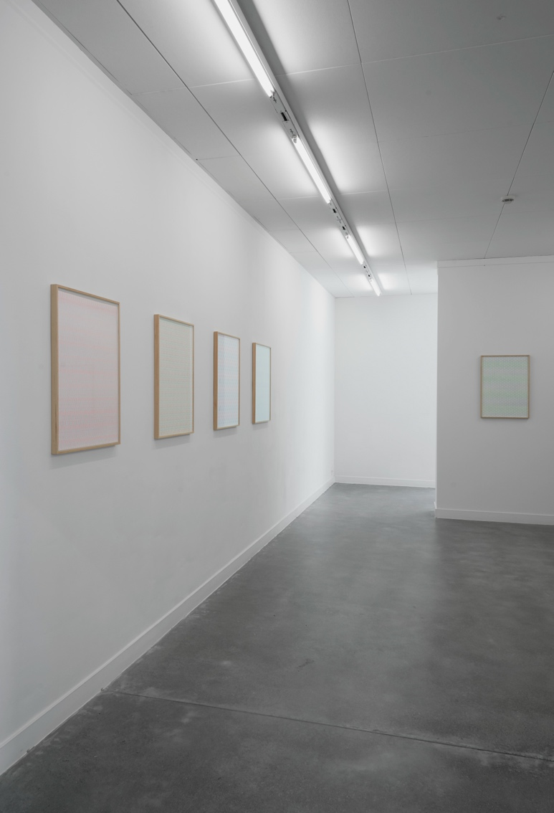
Installation view Kato Six M Leuven, 2022
© M Leuven (photo Dirk Pauwels)

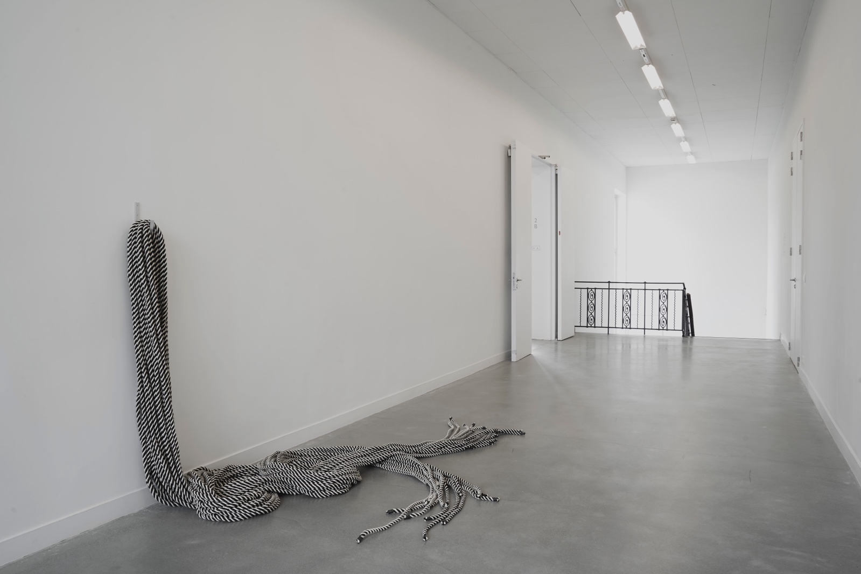
Spinning Lines, Twisting Thoughts, Kato Six, 2018, Collection Mu.ZEE Oostende © M Leuven (photo Dirk Pauwels)

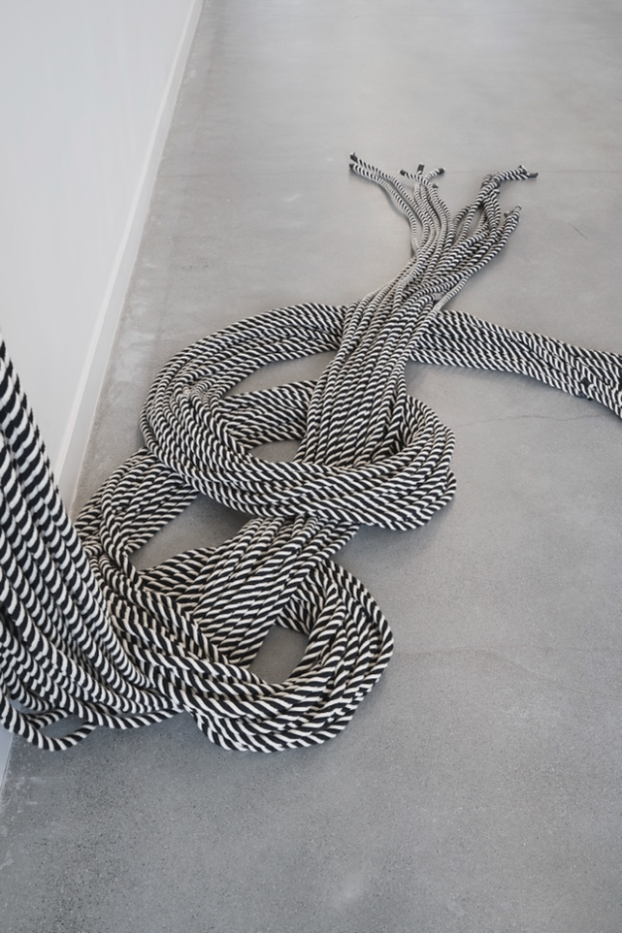
Spinning Lines, Twisting Thoughts, Kato Six, 2018, Collection Mu.ZEE Oostende
© M Leuven (photo Dirk Pauwels)

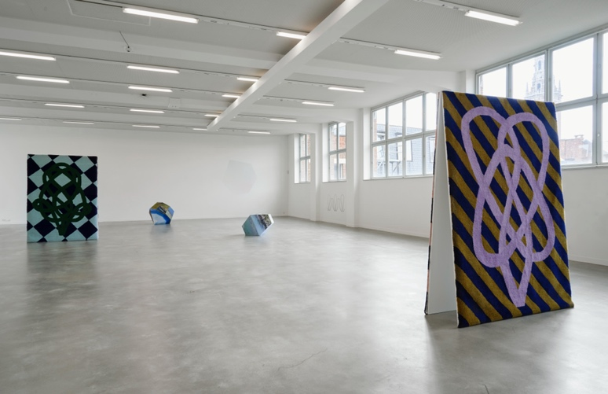
Installation view Kato Six M Leuven, 2022
© M Leuven (photo Dirk Pauwels)
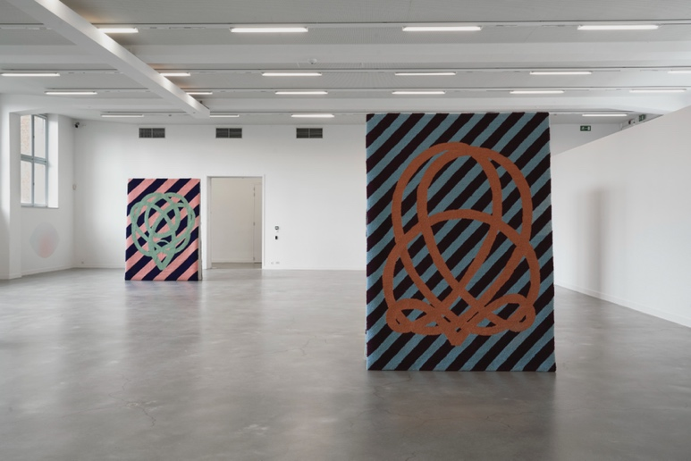
Installation view Kato Six M Leuven, 2022
© M Leuven (photo Dirk Pauwels)
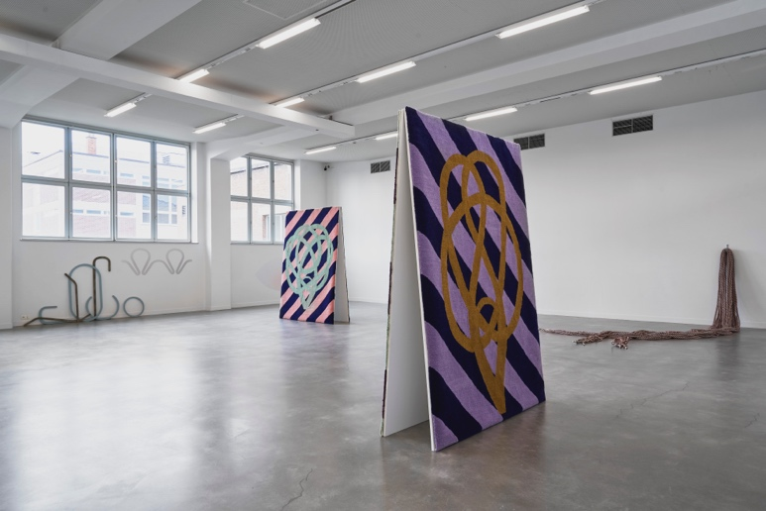
Installation view Kato Six M Leuven, 2022
© M Leuven (photo Dirk Pauwels)
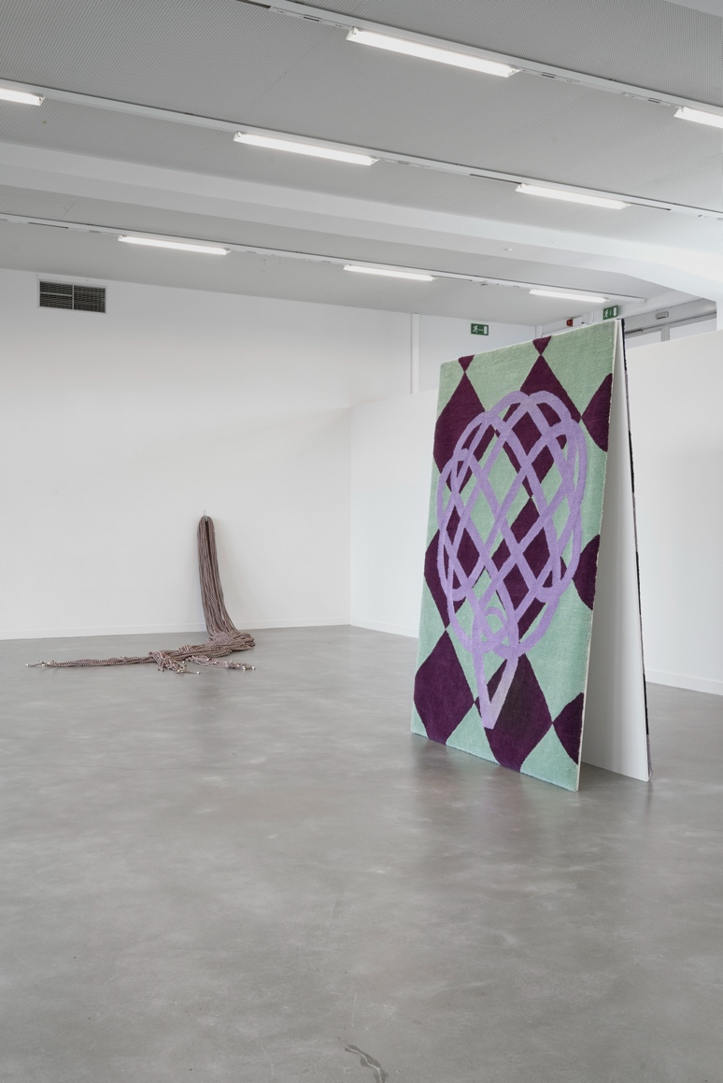
Installation view Kato Six M Leuven, 2022
© M Leuven (photo Dirk Pauwels)
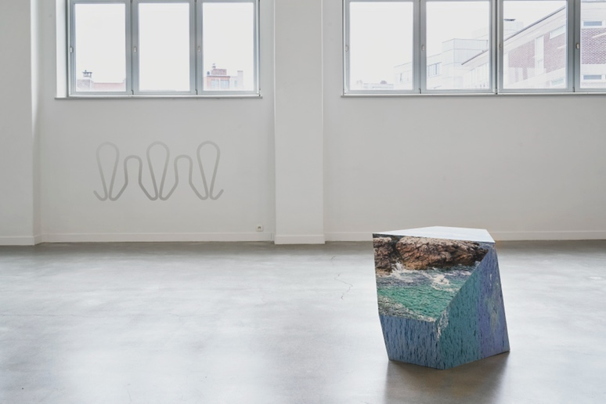
Installation view Kato Six M Leuven, 2022
© M Leuven (photo Dirk Pauwels)

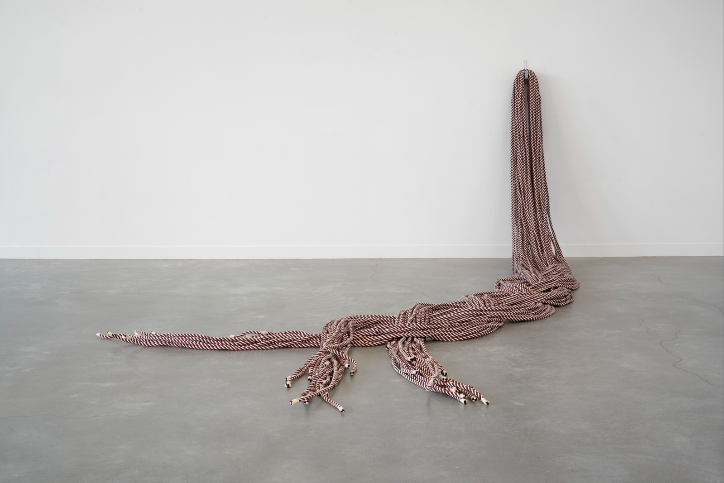
State of Matter, Kato Six, 2019, Courtesy the artist © M Leuven (photo Dirk Pauwels)

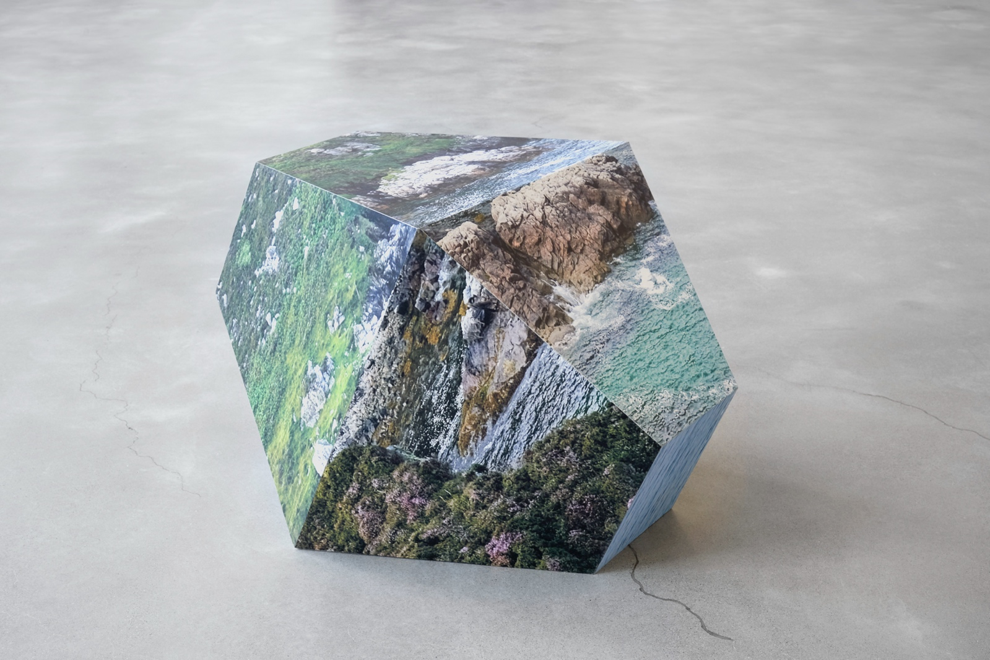
Background Hum, Kato Six, 2016, Cera-collection by M Leuven © M Leuven (photo Dirk Pauwels)
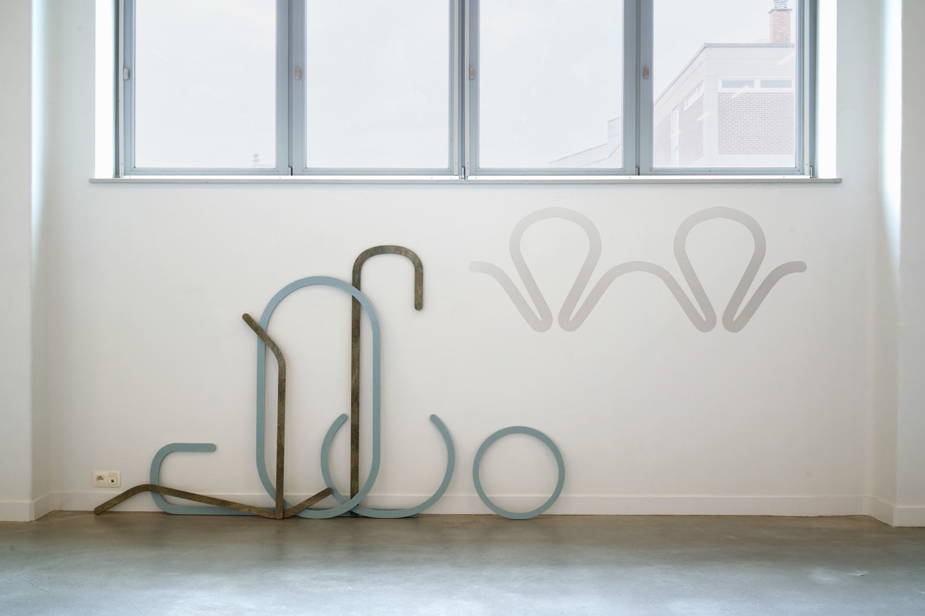
Spinning Lines, Twisting Thoughts, Kato Six, 2017, Flemish Government by M Leuven
© M Leuven (photo Dirk Pauwels)

PUBLICATION
To coincide with the exhibition, M and Posture Editions are publishing the book 'Sawing a plank is like going for a walk', about Kato Six's oeuvre. The publication costs 30 euros and is available at Barbóék in M.

Published by: Posture Editons & M Leuven
Concept, typography and production: Stien Stessens, Nikolaas Demoen, Katrien Daemers and Kato Six
Text: Phillip Van den Bossche, Agata Jasztrzabek (Filarowska), Eva Wittocx
Final editing: Eleonora Ivory Weber (text Filarowska), Het Vertaalcollectief (tekst Eva Wittocx)
Translation: Sis Matthé
(final editing: Clodagh Kinsella)
Photocredits: Sybilla Britani, Sári Ember, Hugard & Vanoverschelde, Yves Ray, Ellen Ryckx, Joost Goethals, Tom Callemin & Dirk Pauwels
Lithography: Cédric Verhelst
Typeset: in Baskerville URW and Acumin Pro printed on
Munken lynx rough and Gmund colors by Antilope De Bie/Graphius Group
ISBN 978 94 9126 251 7
D/2022/12.774/3
This book is supported by M Leuven. The artist is supported by the Flemish Government.

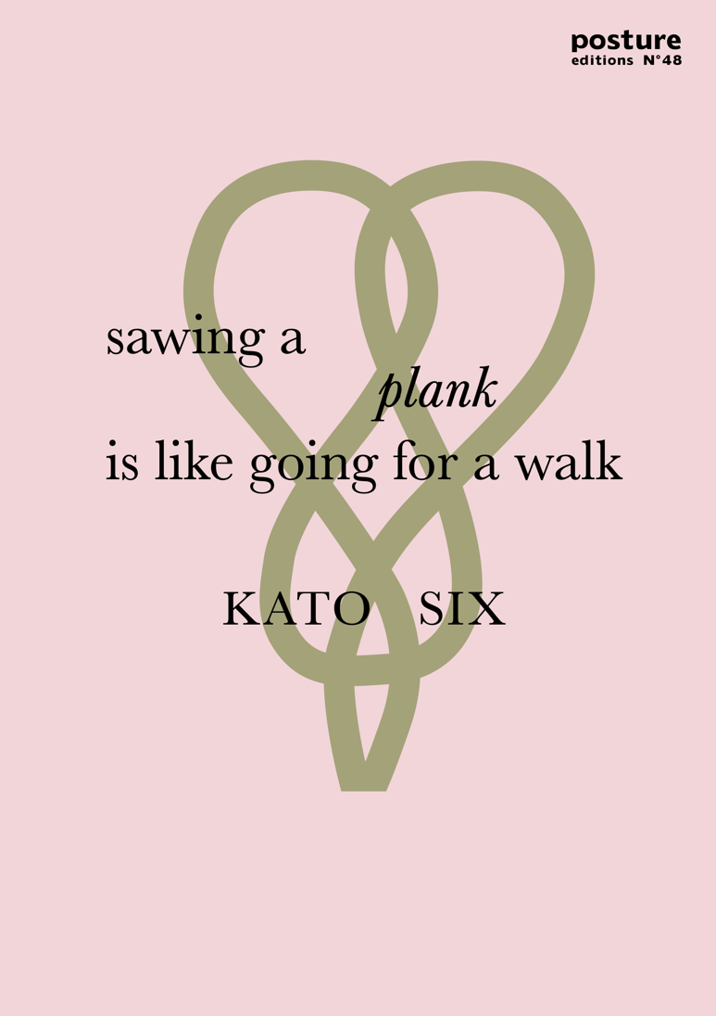

PRACTICAL
M LEUVEN
Vanderkelenstraat 28
3000 Leuven
+32 (16) 27 29 29
info@mleuven.be
www.mleuven.be
Plan your route to the museum
By bike
Cyclists are welcome! Parking is easy. Just use the secure underground bicycle parking at Rector de Somerplein. From there, it’s just a two-minute walk to the museum.
Via public transport
The museum is a ten-minute walk from Leuven Station. Rector de Somerplein is the closest stop if you’re coming by bus. Use Google Maps to plan your route.
By car
Leuven’s new circulation plan leads you into the city and car parks via a series of rings. Would you prefer to avoid the city’s traffic? Just park your car at one of the car parks on Leuven’s outskirts and catch a free bus to the centre. Prefer to park nearby? The Ladeuze car park is only a two-minute walk from the museum. There are also 18 spaces for disabled passengers (higher clearance: 1.90 m). Click here for more information on the circulation plan and parking options.

CONTACT
Hanne Grégoire
Head of Press & Communications
hanne.gregoire@mleuven.be
+32 (0)472 95 52 26

Samantha Fadahunsi
Press & Communications Officer
samantha.fadahunsi@mleuven.be
+32 (0) 491 35 02 95

Webpage links:
https://www.mleuven.be/en/programme/kato-six

Link Prezly:
High-resolution images can be downloaded with this link:
https://mleuven.prezly.com/media

